**Program no____11____**

**Program Title______ smart GAS detector_________**

**Aim vibration motor must vibrate**

**Hardware Required**

* Arduino Board
* NPN transistor
* Vibration moor
* Resistor
* Photoresistor
* multimeter

**Circuit Diagram**

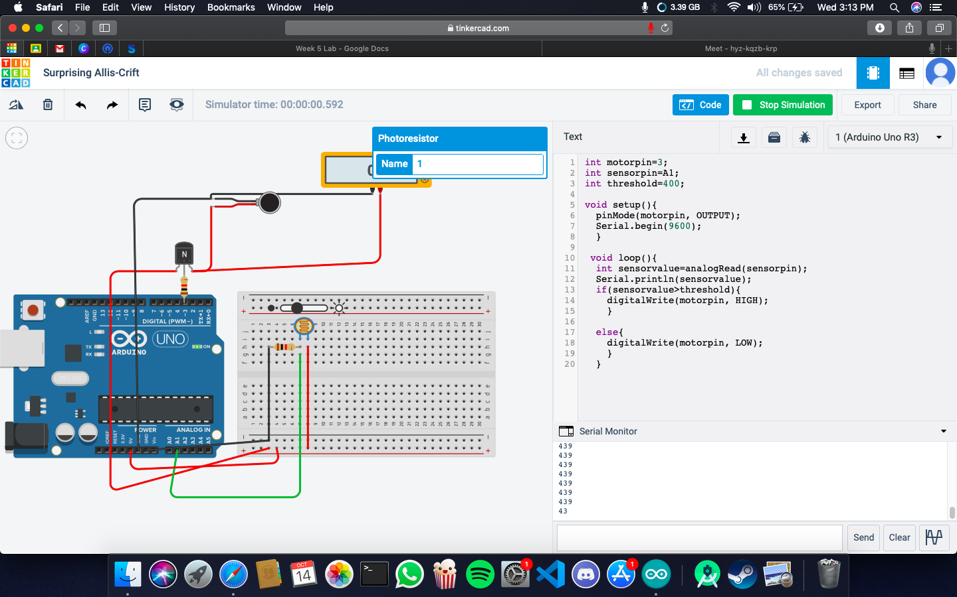

**Code:**

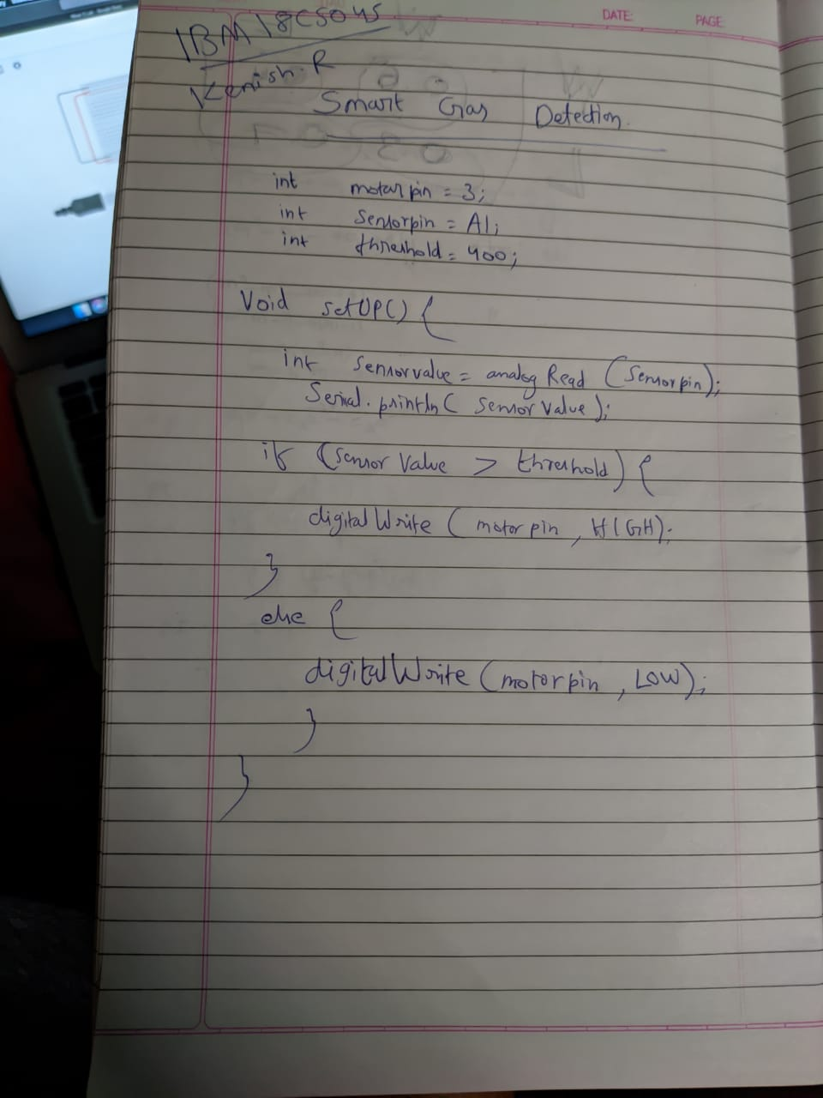

**Observation /Output**

**Vibration motor will vibrate.**